Staff At The Mafou Sanctuary Couldn’t Believe Their Eyes When They Discovered What This Gorilla Was Holding
By John
14 May 2021
Bobo the Gorilla had been at the sanctuary for a long enough time now that the employees knew him well. They were very used to his behaviour at this point, so when he began acting differently, they knew there must be an explanation for it.
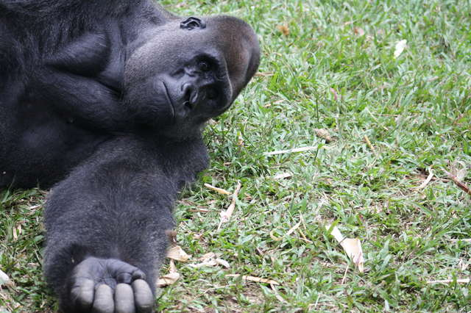
goanimals.co
When they took a closer look, they noticed that his hand was scrunched up. He seemed to be holding something. They needed to find out what it was that he was holding, but they didn’t dare get too close. When they finally figured out what he was holding, it came as quite a surprise to the team. This behaviour was very out of character for an ape.

Bobo The Gorilla
Bobo was only small when he arrived at the Mefou Primate Sanctuary. He was just two years-old at the time and had witnessed his mother being taken away by poachers. The poor baby gorilla had been left motherless and alone.
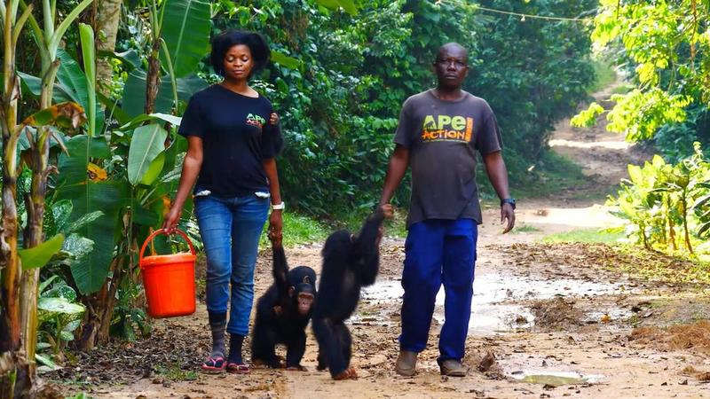
Gerry Ellis/Apes Like Us
A few years had passed and Bobo was now a full-grown adult. The sanctuary was what he knew to be home and he had become the alpha gorilla there. One thing was for sure, no poachers would dare mess with him now!

Kind-Hearted Ape
Bobo was a big gorilla. He weighed over 300 pounds. This seems like quite an intimidating prospect, but Bobo had a very sweet temperament. He was good-natured and treated both the staff and his fellow apes with kindness.
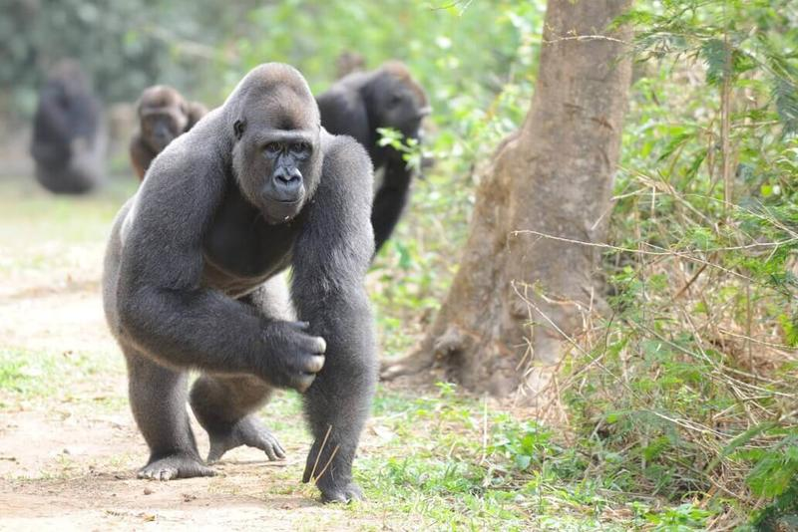
Ape Action Africa
In spite of this, he was still determined to become the alpha of the group, as is the case for all male apes like Bobo. He had made it to the top of the pecking order and there was no way he was going to let anyone take his title without a fight.

Suspicious Behaviour
"Younger males Kibu and Nkamum once challenged Bobo for his position, they were never successful and no longer attempt to take control," explained Elissa, a sanctuary employee who takes care of Bobo. When Bobo started acting strangely, the caretakers became concerned. What was he up to?
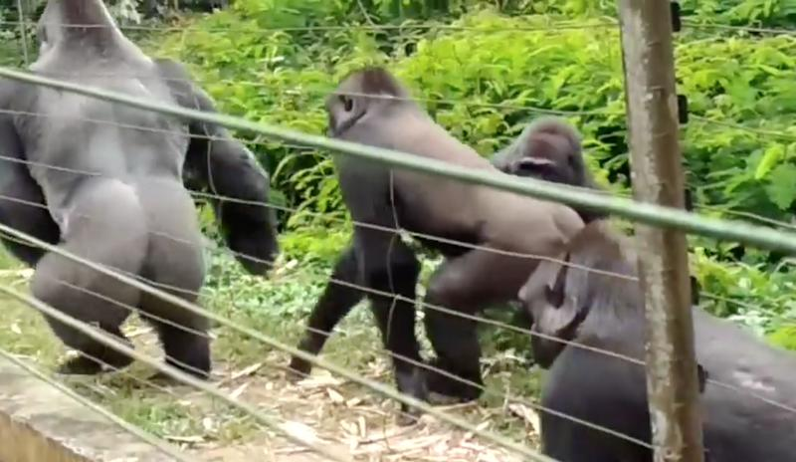
The sanctuary was funded by a charity called Ape Action Africa. It is home to over 300 apes and monkeys. Elissa had been the one to raise Bobo so she knew him very well. When he started acting up she made sure to keep an eye on him and his primates, in case they were in any sort of danger.

Hiding Something
Up until this point, Bobo had always wandered around the enclosure with such confidence. He would now often be spotted hiding in the long grass whenever the gates to the sanctuary closed. Why did he do this? What was he hiding from?
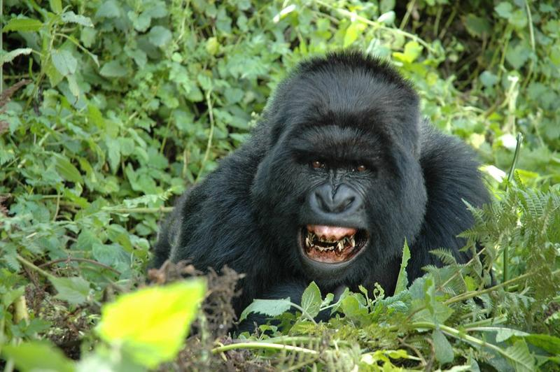
Elissa wanted answers so she watched him intently and as she watched, she realised that Bobo wasn't trying to hide himself in the grass, rather he appeared to be hiding something that he didn't want anyone to see. She had to find out what it was.

Committed Staff
All of the apes that lived in the sanctuary had been traumatised prior to arriving, in one way or another. This is why it was so important to find out exactly what it was that was effecting Bobo and, consequently, his behaviour.
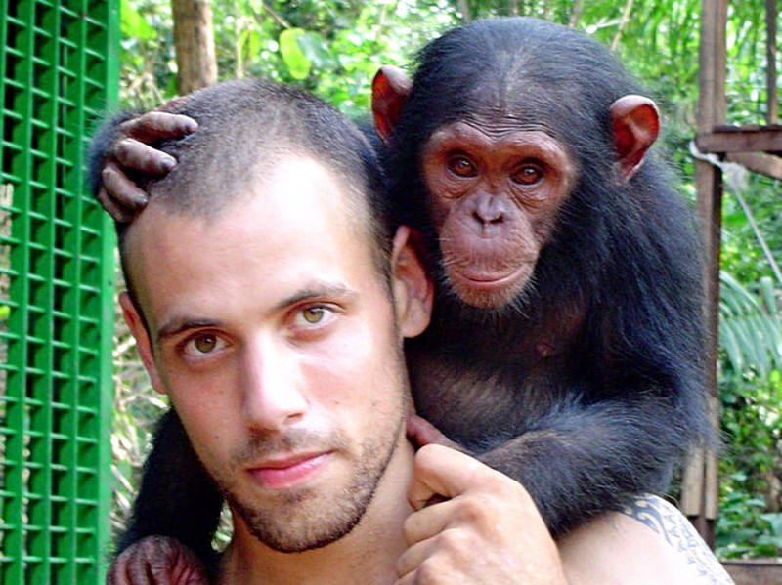
Mefou Primate Sanctuary was opened as a result of a rise in popularity of illegal bushmeat and animal trade. The devoted and passionate staff were looking out for the primates of Cameroon. They swore to do everything in their power to protect them.

Investigating
The sanctuary staff were very well equipped to deal with the post-traumatic stress that many of these apes were suffering from. They had undergone training especially for this. They wanted the apes to be as comfortable in the sanctuary as possible.
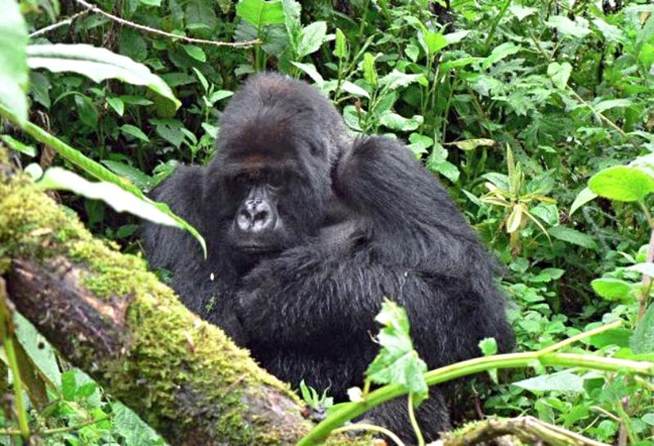
All of the staff were quite concerned about Bobo at this point. They needed to find out what was really up. Elissa waited until he had left the grassy patch he had started going to and went to investigate it herself. She breathed a sigh of relief when she found nothing there. She would later realise that the object Bobo was so keen to hide, he always kept close to him. Whatever it was, he didn't want to let it out of his sight.

Tiny Creature
Bobo was usually very friendly towards the staff at the sanctuary, but whenever Elissa tried to get close to him, he would try and get as far away from her as possible. She eventually managed to get close enough to be able to see what he was fussing about. It turned out that he was tending to another living creature.
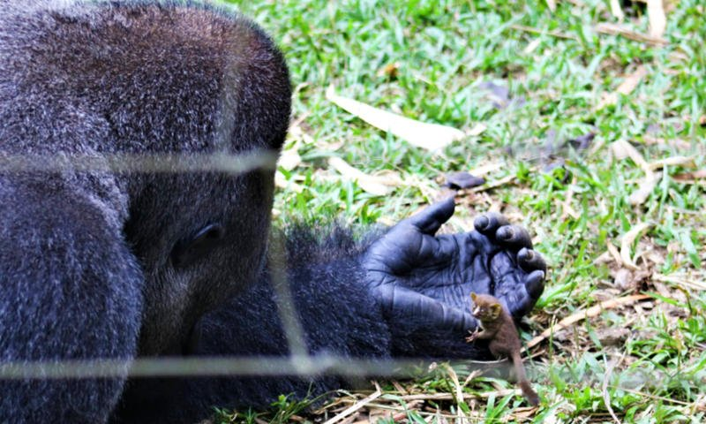
As soon as he realised he was being watched, he got spooked and headed off into the overgrown grass. Elissa was unable to identify the crying creature from a distance. She needed to come up with a plan so that she could get to the bottom of Bobo's strange behaviour.

Where Did It Come From?
The furry little animal seemed perfectly content with the giant gorilla, despite the fact that he was being continuously prodded and poked. This struck the staff as strange, since a rodent would be more likely to scurry away. Elissa wondered whether it might have been injured. Upon taking a closer look, she realised that it wasn't a rodent after all. This tiny creature was actually a primate too.
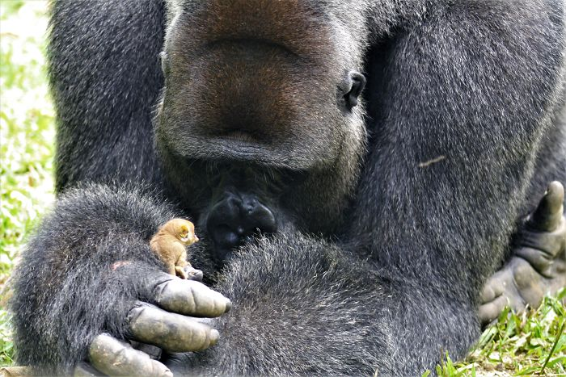
The sanctuary took care of so many apes, so you would expect that they might lose track of one every once in a while. However, at Mefou, this wasn't something that happened, since they took such care of each individual animal. This suggested that the primate in Bobo's hands didn't actually come from the sanctuary. So, where had it come from?

Bush Baby
The primate they were studying was a galago. The staff came to the conclusion that the creature must have found its way into the sanctuary from the forest which surrounded the enclosure. The galago, also known as a "bush baby" - due to the crying sounds they make - wasn't usually the kind of primate they took care of at Mefou. While Bobo had clearly formed a close bond with the little creature, they couldn't let him look after it.
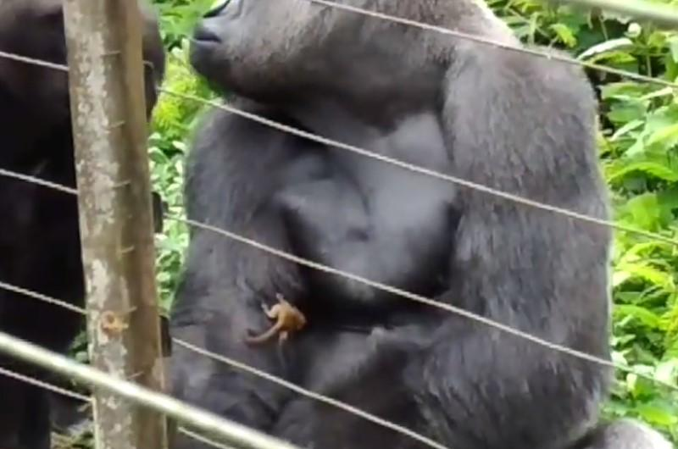
"The bush baby showed no fear of Bobo, moving around his body and spending time hopping around in an open grassy area before choosing to return to Bobo," said Elissa. She wasn't just taken aback by the special treatment Bobo was giving the galago...

A Rare Sight
"Bush babies are usually nocturnal so it is very rare to see one, and even rarer to witness this kind of interaction," Elissa continued. Galagos tend to hunt and feed in the dark, so seeing one being fed breakfast by a gorilla was an incredible sight to behold.
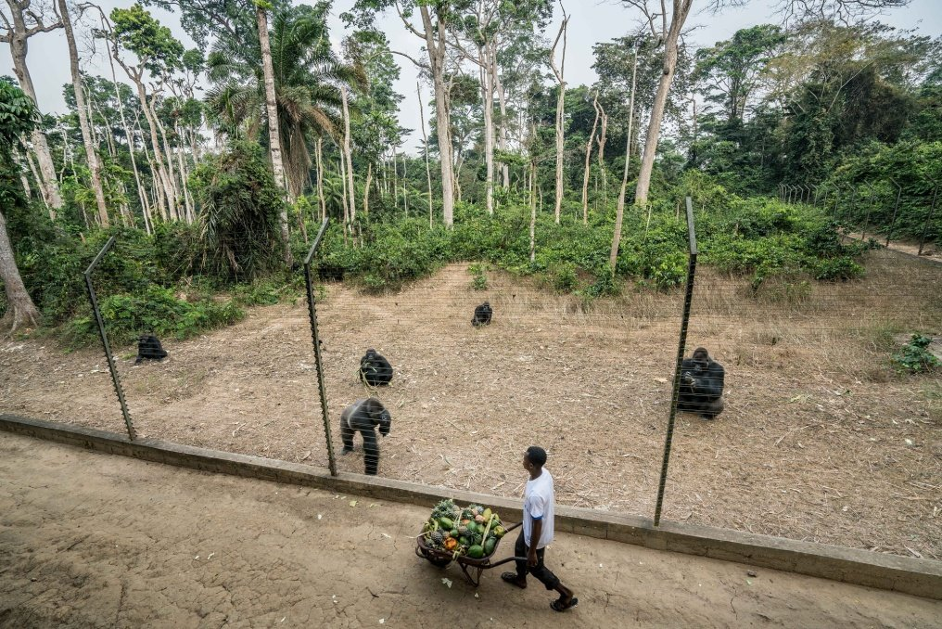
"Wild primates and rescued ones seldom interact with each other like this. They're either at a sanctuary or they're in the jungle. We have never witnessed a wild primate interacting with a rescued one," said Elissa. The unique positioning of Mefou's enclosures by the forest made for a once-in-a-lifetime encounter between a tiny wildling and giant friendly gorilla. This soon became a huge attraction for the other apes.

Content
"The little bush baby was happy to play in Bobo's arms, hopping off to explore the grass nearby, before returning to Bobo's hand," Elissa explained. It wasn't long before the other primates realised what Bobo was up to. The more curious among them moved in to get a closer look.
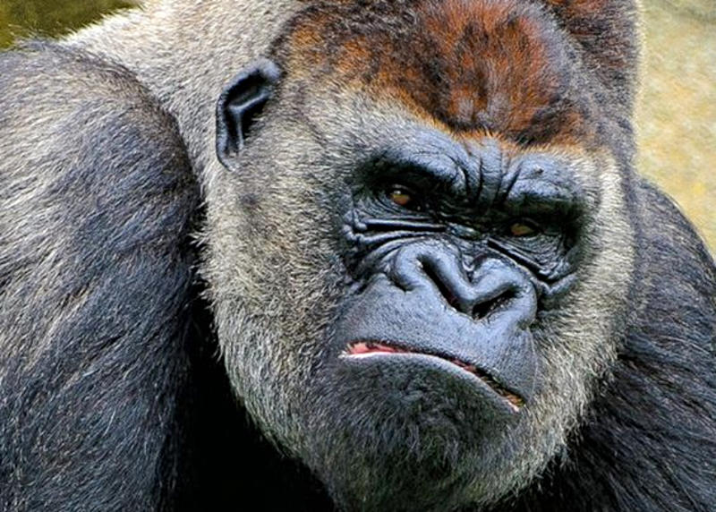
"Bobo's group-mates were desperately curious, but he kept them all at a distance, making sure no one disturbed his new friend," said Elissa. It dawned on Bobo that his little friend might want to return to his natural habitat, so he lifted him up to the tree branch which hung over the enclosure. Elissa was ecstatic that they'd managed to catch all of this on camera and that all was well with the apes.

Video Went Viral
The staff managed to capture every moment of the unique experience. They posted it on Facebook, along with the caption: "Our silverback gorilla Bobo made a surprising new friend this week - a wild bush baby!... Caregivers discovered him cradling the tiny primate during their morning checks, and were amazed to see him handling it with the utmost care."
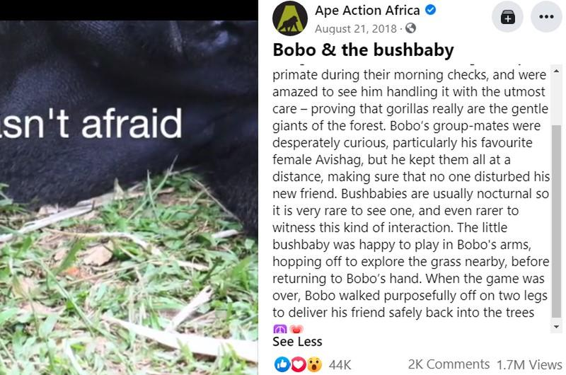
As you can imagine, it wasn't long before the video had gone viral. It ended up accumulating over 2,000 comments and around 1.7 million views. People from all over the world and all walks of life were touched by the heartwarming interaction between Bobo and his little friend. Many were quick to point out that Bobo was displaying a characteristic that all of us could learn from...

Empathetic Animals
"These gorillas have a very nurturing and empathetic nature, the human race could learn from these beautiful, thoughtful animals," one user wrote. "Exactly why I love gorillas... because they're amazingly gentle giants who are extremely intelligent animals," another commented. That's why it's so important to protect this endangered species.
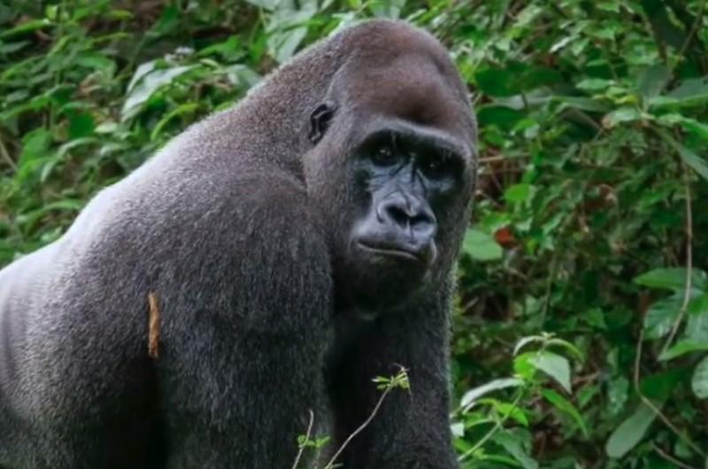
Unfortunately, these great apes are under threat all over the Congo basin due to forest conversion to industrial agriculture projects. There are two species of gorilla - the eastern gorilla and western gorilla. These are each divided into two subspecies - eastern lowland gorilla and mountain gorilla, and western lowland gorilla and cross river gorilla.

Intelligent Beings
Gorillas are very intelligent. While they don't use tools as much as chimpanzees do, they have been seen using sticks to gauge water depth, bamboos as ladders to help infants climb, and they have recently been spotted using sticks in order to eat ants and avoid being stung. The gorilla's impressive communication abilities are another sign of their intelligence. They've been recorded making some 25 different sounds.
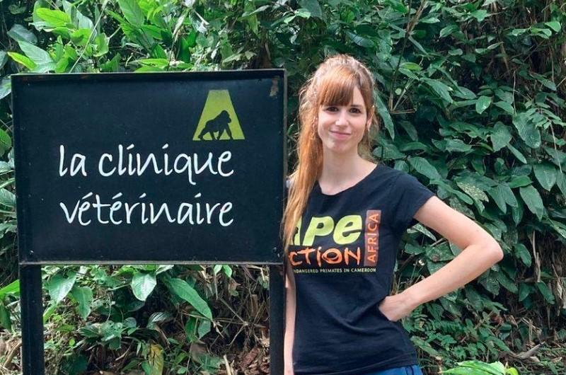
We share 98.3% of our DNA with gorillas. This makes them our closest relatives after chimpanzees and bonobos. Unfortunately, gorillas are actually among the world's most endangered animals. Charity organisations in Cameroon have made it their mission to try and change that. However, as you can imagine, a sanctuary so large needs a huge amount of funding to be able to continue their work. They rely on volunteers and donations from the public.

Important Work
Ape Action Africa was established back in 1996. It began as a UK charity called Cameroon Wildlife Aid Fund, otherwise known as CWAF. The charity's main goal was to improve living conditions for primates housed at Mvog-Betsi Zoo in Yaoundé, Cameroon. They later decided to open up a sanctuary for wild orphans of the illegal bushmeat trade, like Bobo.
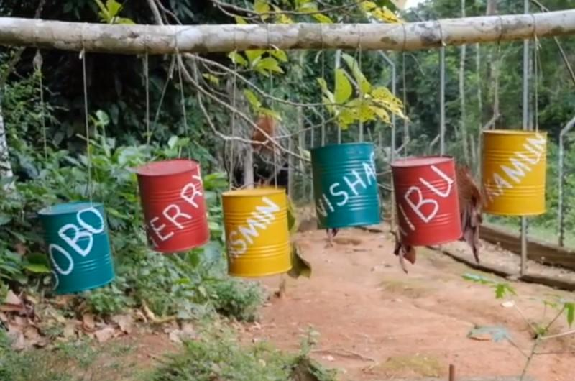
With more than 300 primates under its care, Ape Action Africa is now one of the largest conservation projects of its kind in Africa. One established gorilla group in the Mefou Primate Sanctuary is known as Bobo's group. This consists of the Silverback, Bobo, two black backs, Kibu and Nkamum, three females' Jasmine, Geri Avishag and her juvenile Eto-fils.

Vulnerable Species
Bobo's rise to Internet fame has helped to raise awareness for these animals and the constant threat they face from poachers. The work of charities like CWAF is vital in helping to preserve the life of these gorillas and future generations of gorillas.
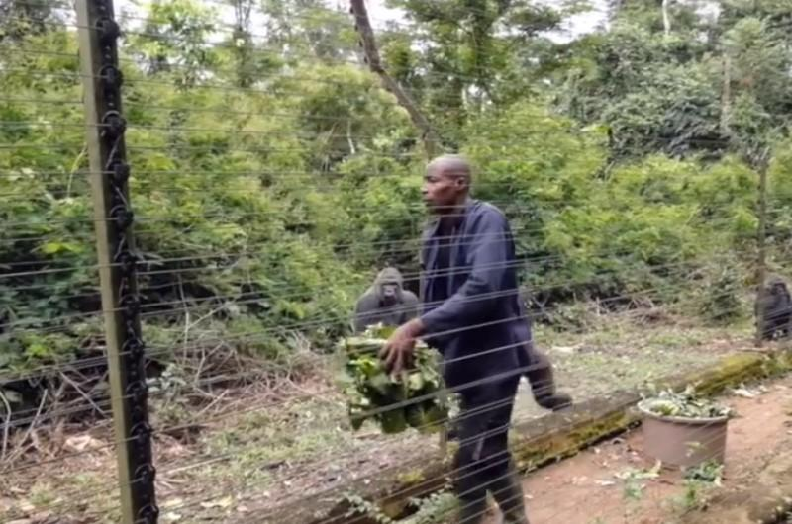
Another major threat that these gorillas face is the loss of their habitat. Cameroon has more than 20 million hectares of tropical rainforest, but this is quickly disappearing, due to unsustainable foresting and poaching practices. Fortunately, all is not lost...

Fighting Extinction
Despite the fact that gorillas are still on the endangered species list, there is still hope yet. If we can continue to raise awareness around these issues then we might have a chance at preventing the extinction of these incredible creatures.
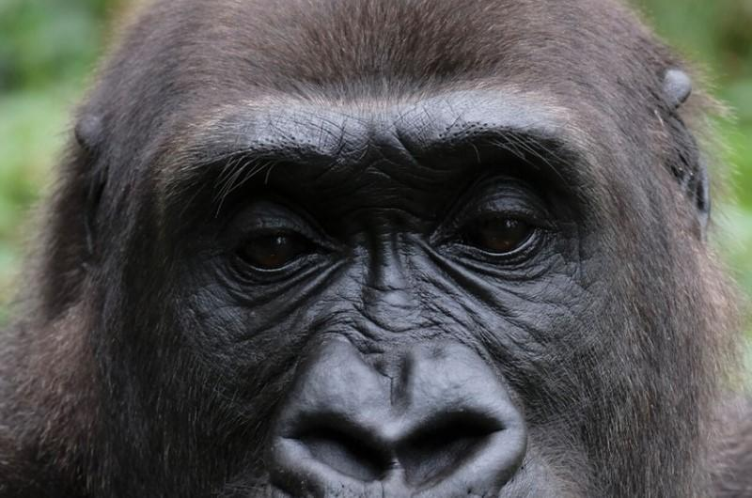
Sir David Attenborough, who first visited Cameroon in 1979, said, "It is incredibly heartening to see how the efforts of so many groups - communities, governments, NGOs - have paid off. The threats to mountain gorillas haven't disappeared entirely, of course, so now the challenge must be to ensure that these achievements are sustained long into the future."

Mountain Gorillas
There are around 1,063 mountain gorillas which continue to exist in the world today. They tend to be found in high altitude montane and bamboo forests, which are typically surrounded by agriculture and settlements.
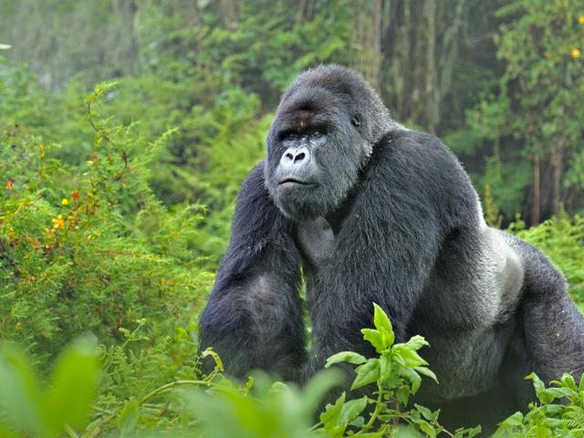
Since gorillas are so similar genetically to humans, exposure to human illnesses - even just a cold - can have a devastating impact on them. This is because unlike us, they haven't developed the necessary immunities.

More On Mountain Gorillas
Gorillas survive on a diet which consists mainly of leaves and shoots, but have also been known to eat snails, ants and bark. They are sensitive, sociable beings who cosy up together at night. Infants sleep cuddled up to their parents to keep themselves nice and warm.
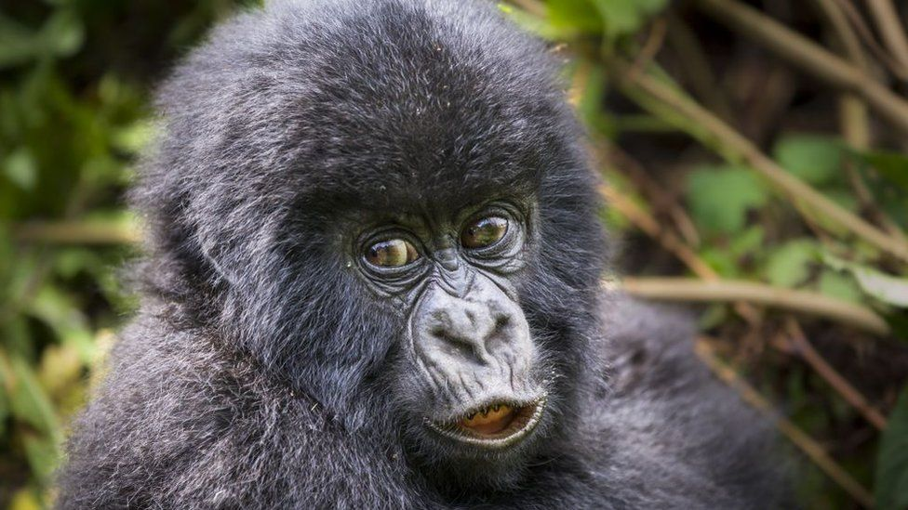
They live in family groups, which can consist of up to 10 individuals, comprised of one dominant male and several females. Interestingly, males also care for their infants, hugging them, carrying them and playing with them.

